**Project Report**

**The Restaurant Site**

**By**

**Sudhanshu Nimje(RA1711003011318)**

**Manvi Singh Chandel(RA1711003011471)**

**Introduction:-**

For our Web programming project we have created a Restaurant website of Adare in which people can make reservations for dining. It requires the user to register on the site and create an account,by becoming a member the users can make booking multiple times.

In the home page we have options of Menu, Chef’s , Contact and Blog on display.

Through Menu page the user can select what they would like to have from a variety of burgers,sandwiches, pastas and cheese fries.

Under that the map is displayed for the exact location so users can easily locate the restaurant.

There are also details mentioned about the talented chef’s working here. About their experience and years of service under the chef’s column.

Through the blog page users can read about certain recipes which are quick and easy to make, some of which are right from our own chef’s kitchen.

Finally the contact page through which people can contact the management if they have any queries.

Under this there is also a feedback form for the users to share their experience,suggestions and if they had any issue regarding the service they received.

For the feedback form the various factors to rate include: Food experience, Staff support,Cleanliness, overall service quality etc

**Database connectivity**

Language used:-PHP and MySql

Title: Registration System Php and Mysql

For the Registration Form:-1)Initializing variables such as username,email id and password.

1. Connecting to database and receiving all input values.

Checking through Sql queries:-

1. Validating the form:-i)Confirming password ( the two passwords need to match If not error message is shown )

ii)Validating other details(username, email id) and making sure they do not exist already.

iii)If user already exists, error message is shown.

4) If none of the errors are displayed the user can finally register.

5)After registration the message is displayed saying the user is logged in.

6)Also there is another link(Sign in) for directly logging if you’re already a member.

For Login Page:- 1) Enter the username and password if you’re already a member.

1. If any of the two are incorrect, error message is displayed.
2. If both are correct user is able to login.
3. Also if you are a first time user and have not registered yet you can use the link below the password label for signing up.
4. This link will connect you to the registration page.

Server.php

<?php

session_start();

// initializing variables

$username = "";

$email    = "";

$errors = array();

// connect to the database

$db = mysqli_connect('localhost', 'root', '', 'registration');

// REGISTER USER

if (isset($_POST['reg_user'])) {

  // receive all input values from the form

  $username = mysqli_real_escape_string($db, $_POST['username']);

  $email = mysqli_real_escape_string($db, $_POST['email']);

  $password_1 = mysqli_real_escape_string($db, $_POST['password_1']);

  $password_2 = mysqli_real_escape_string($db, $_POST['password_2']);

  // form validation: ensure that the form is correctly filled ...

  // by adding (array_push()) corresponding error unto $errors array

  if (empty($username)) { array_push($errors, "Username is required"); }

  if (empty($email)) { array_push($errors, "Email is required"); }

  if (empty($password_1)) { array_push($errors, "Password is required"); }

  if ($password_1 != $password_2) {

  array_push($errors, "The two passwords do not match");

  }

  // first check the database to make sure

  // a user does not already exist with the same username and/or email

  $user_check_query = "SELECT * FROM users WHERE username='$username' OR email='$email' LIMIT 1";

  $result = mysqli_query($db, $user_check_query);

  $user = mysqli_fetch_assoc($result);

  if ($user) { // if user exists

    if ($user['username'] === $username) {

      array_push($errors, "Username already exists");

    }

    if ($user['email'] === $email) {

      array_push($errors, "email already exists");

    }

  }

  // Finally, register user if there are no errors in the form

  if (count($errors) == 0) {

    $password = md5($password_1);//encrypt the password before saving in the database

    $query = "INSERT INTO users (username, email, password)

          VALUES('$username', '$email', '$password')";

    mysqli_query($db, $query);

    $_SESSION['username'] = $username;

    $_SESSION['success'] = "You are now logged in";

    header('location: index.php');

  }

}

// LOGIN USER

if (isset($_POST['login_user'])) {

    $username = mysqli_real_escape_string($db, $_POST['username']);

    $password = mysqli_real_escape_string($db, $_POST['password']);

    if (empty($username)) {

        array_push($errors, "Username is required");

    }

    if (empty($password)) {

        array_push($errors, "Password is required");

    }

    if (count($errors) == 0) {

        $password = md5($password);

        $query = "SELECT * FROM users WHERE username='$username' AND password='$password'";

        $results = mysqli_query($db, $query);

        if (mysqli_num_rows($results) == 1) {

          $_SESSION['username'] = $username;

          $_SESSION['success'] = "You are now logged in";

          header('location: index.php');

        }else {

            array_push($errors, "Wrong username/password combination");

        }

    }

  }

  ?>

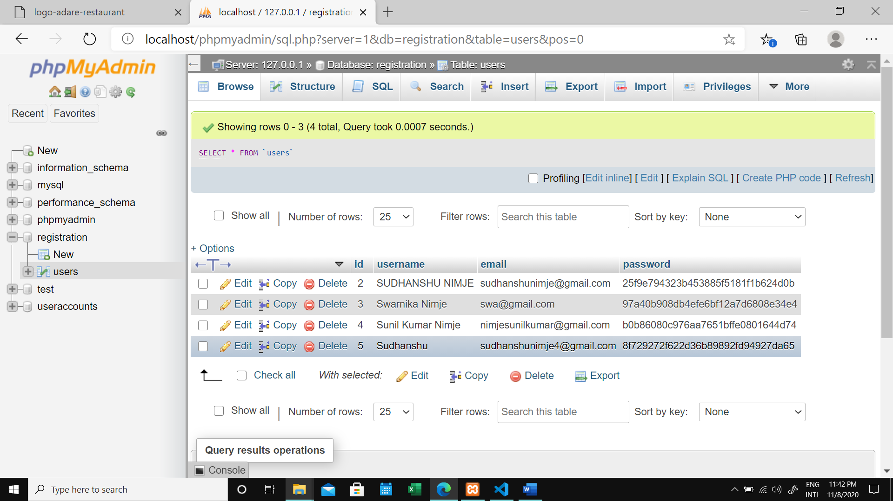

Register.php

<?php include('server.php') ?>

<!DOCTYPE html>

<html>

<head>

  <title>Registration system PHP and MySQL</title>

  <link rel="stylesheet" type="text/css" href="style.css">

</head>

<body>

  <div class="header">

    <h2>Register</h2>

  </div>

  <form method="post" action="register.php">

    <?php include('errors.php'); ?>

    <div class="input-group">

      <label>Username</label>

      <input type="text" name="username" value="<?php echo $username; ?>">

    </div>

    <div class="input-group">

      <label>Email</label>

      <input type="email" name="email" value="<?php echo $email; ?>">

    </div>

    <div class="input-group">

      <label>Password</label>

      <input type="password" name="password_1">

    </div>

    <div class="input-group">

      <label>Confirm password</label>

      <input type="password" name="password_2">

    </div>

    <div class="input-group">

      <button type="submit" class="btn" name="reg_user">Register</button>

    </div>

    <p>

        Already a member? <a href="login.php">Sign in</a>

    </p>

  </form>

</body>

</html>

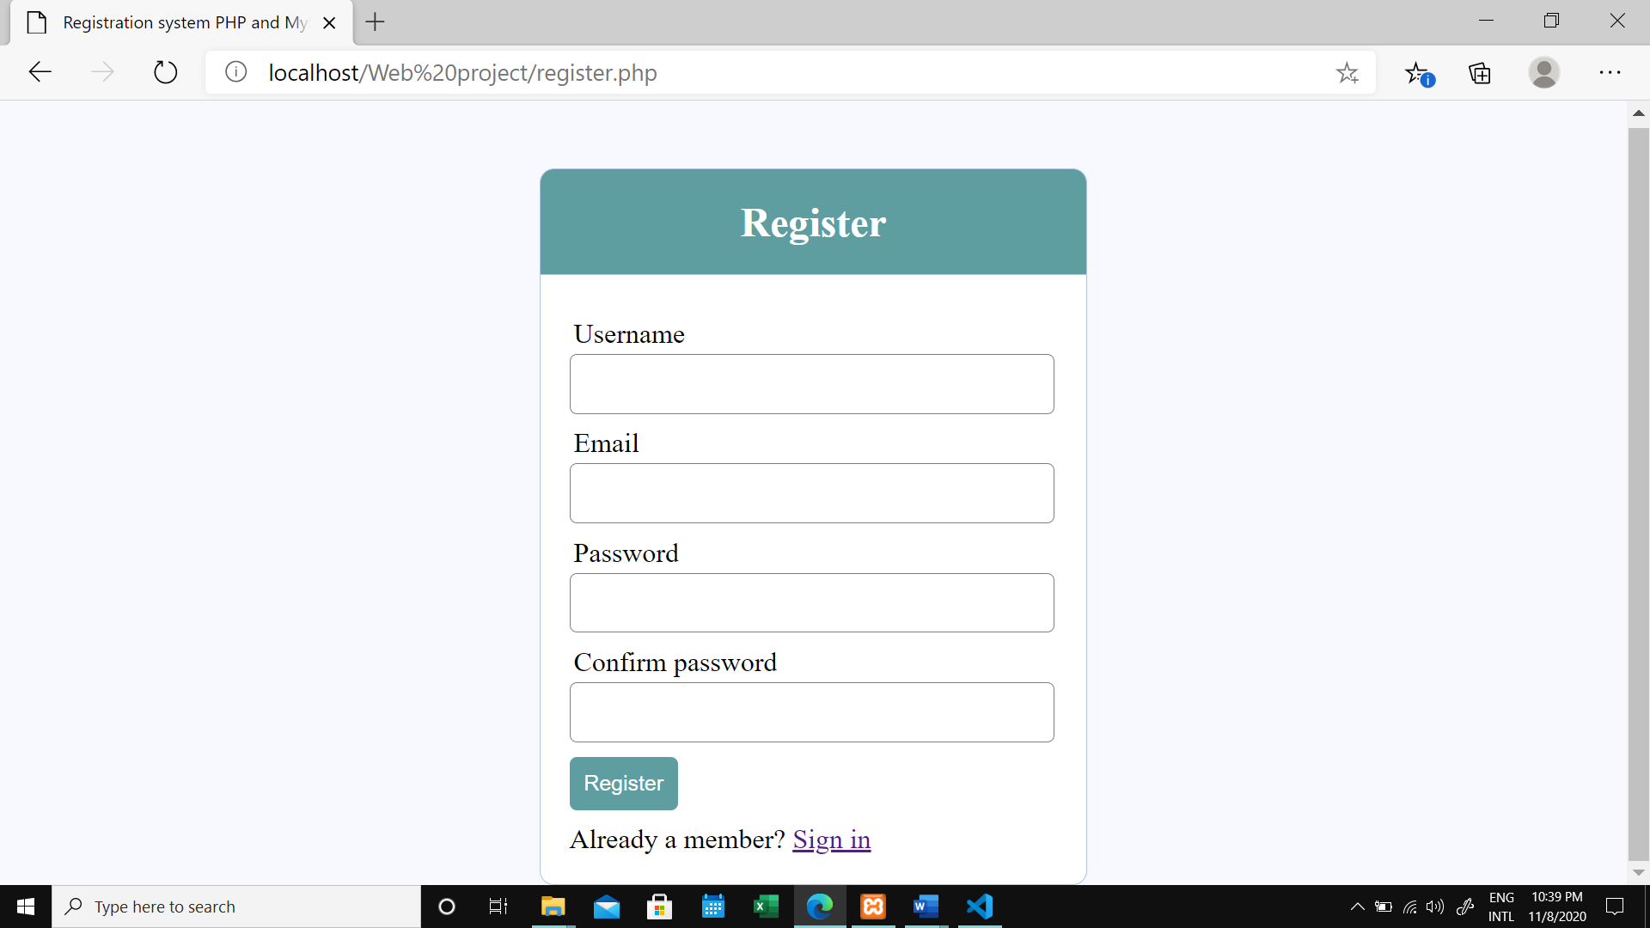

Login.php

<?php include('server.php') ?>

<!DOCTYPE html>

<html>

<head>

  <title>Registration system PHP and MySQL</title>

  <link rel="stylesheet" type="text/css" href="style.css">

</head>

<body>

  <div class="header">

    <h2>Login</h2>

  </div>

  <form method="post" action="login.php">

    <?php include('errors.php'); ?>

    <div class="input-group">

        <label>Username</label>

        <input type="text" name="username" >

    </div>

    <div class="input-group">

        <label>Password</label>

        <input type="password" name="password">

    </div>

    <div class="input-group">

        <button type="submit" class="btn" name="login_user">Login</button>

    </div>

    <p>

        Not yet a member? <a href="register.php">Sign up</a>

    </p>

  </form>

</body>

</html>

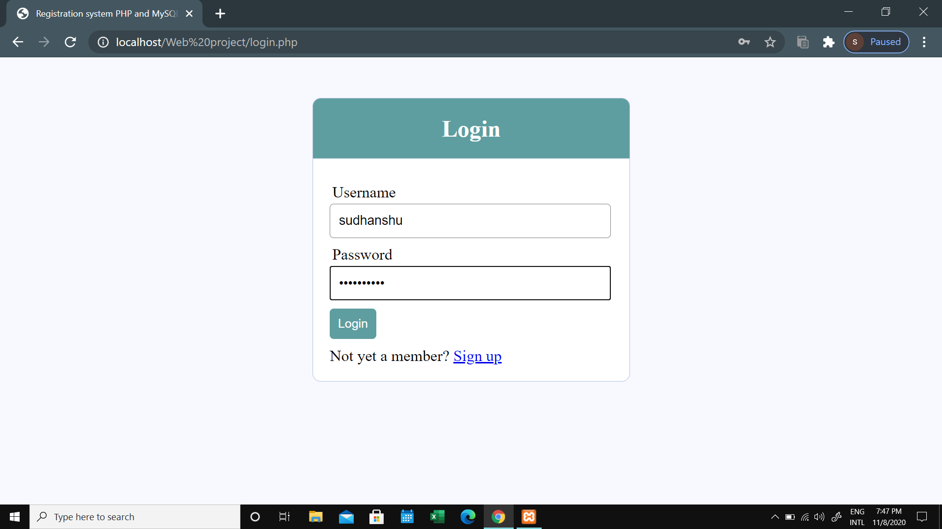

Error.php

<?php  if (count($errors) > 0) : ?>

  <div class="error">

    <?php foreach ($errors as $error) : ?>

      <p><?php echo $error ?></p>

    <?php endforeach ?>

  </div>

<?php  endif ?>

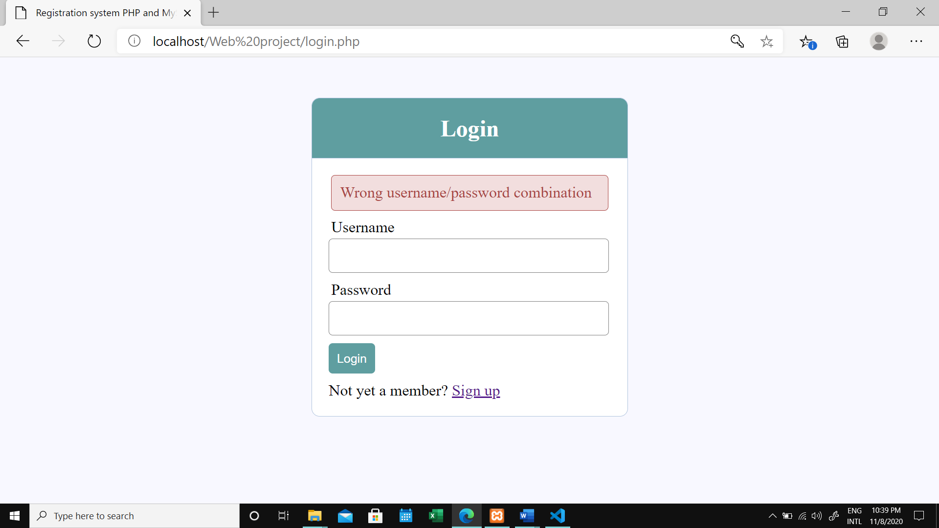

**Home page**

Language used: - HTML5, CSS, JavaScript, PHP.

* Home Page contains the highly interactive interface where you can find the location of the Restaurant and make reservation.
* Home also contains media element (video) which plays as soon as you login.
* PHP is also implemented to fetch the name of the user which is displayed in top right corner and the logout button to get out of session.

HTML code

Index.php

<?php

  session_start();

  if (!isset($_SESSION['username'])) {

    $_SESSION['msg'] = "You must log in first";

    header('location: login.php');

  }

  if (isset($_GET['logout'])) {

    session_destroy();

    unset($_SESSION['username']);

    header("location: login.php");

  }

?>

<!DOCTYPE html>

<html lang="en">

<head>

    <meta charset="UTF-8">

    <meta name="viewport" content="width=device-width, initial-scale=1.0">

    <meta http-equiv="X-UA-Compatible" content="ie=edge">

    <title>logo-adare-restaurant</title>

    <link rel="stylesheet" href="style3.css">

</head>

<body>

    <div class="reg">

        <?php  if (isset($_SESSION['username'])) : ?>

        <p>Welcome <strong><?php echo $_SESSION['username']; ?></strong></p>

        <a href="index.php?logout='1'" style="color: red;">logout</a>

        <?php endif ?>

    </div>

    <div class="container">

        <header>

            <img src="images/logo-adare-restaurant.png" alt="Logo for Adare Restaurant">

        </header>

        <nav>

                <a href="index.php">HOME</a>

                <a href="menu1.html">MENU</a>

                <a href="chefs.html">CHEF'S</a>

                <a href="blog.html">BLOG</a>

                <a href="contact.html">CONTACT</a>

        </nav>

        <main>

            <h1>let's meat</h1>

            <p>We love sharing good food with great people. We bring over 30 years industry experience and passion to <a href="#">Adare.</a> With a dishes that are carefully designed to bring you a truly satisfying Irish food experience that you are sure to remember.</p>

            <a href="https://forms.gle/NP9XzQm8cxS6e4wo6">MAKE RESERVATION</a>

            <br>

            <br>

            <video width="600" autoplay loop>

            <source src="videos/serving.mp4" type="video/mp4">

            </video>

        </main>

        <div><br><br><br><br><br><br><br><br><br><br><br><br><br><br><br><br><br><br></div>

        <section class="maps">

            <iframe src="https://www.google.com/maps/embed?pb=!1m18!1m12!1m3!1d9701.147967093066!2d-8.78819961509965!3d52.56467476732047!2m3!1f0!2f0!3f0!3m2!1i1024!2i768!4f13.1!3m3!1m2!1s0x485b460ddb875af7%3A0xdb34accde986ee58!2sThe+Carriage+House+at+Adare+Manor!5e0!3m2!1sen!2sie!4v1558038906067!5m2!1sen!2sie" width="1024" height="500" frameborder="0" style="border:0" allowfullscreen></iframe>

        </section>

        <footer>

            <p>Main St, Blackabbey, Adare, Co. Limerick - Copyright 2020©</p>

        </footer>

    </div>

</body>

</html>

Style3.css

html {

    height: 100%;

}

body {

    background-color: #2F3035;

    background-image: url(images/background-adare-restaurant.jpg);

    background-size: cover;

    background-repeat: no-repeat;

    background-position: center;

}

.container {

    margin-left: auto;

    margin-right: auto;

    width: 1024px;

}

header {

    height: 118px;

    text-align: center;

}

nav {

    background-color: rgba(0, 0, 0, 0.338);

    text-align: center;

    padding-top: 14px;

    padding-bottom: 14px;

}

main {

    height: 400px;

    text-align: center;

    padding-top: 80px;

    padding-left: 240px;

    padding-right: 240px;

}

footer {

    background-color: rgba(0, 0, 0, 0.728);

    padding-top: 50px;

    padding-bottom: 50px;

}

h1 {

    font-size: 84px;

    color: white;

    font-family: Arial, Helvetica, sans-serif;

}

p {

    font-size: 18px;

    color: white;

    font-family: Arial, Helvetica, sans-serif;

}

a {

    color: white;

    font-family: Arial, Helvetica, sans-serif;

    /* text-decoration: none; */

}

nav a {

    text-decoration: none;

    font-size: 12px;

    padding-left: 10px;

    padding-right: 10px;

}

footer p {

    font-size: 10px;

    text-align: center;

    color: rgb(198, 198, 198);

}

.video {

    align-items: center;

}

.maps {

    padding-bottom: 100px;

}

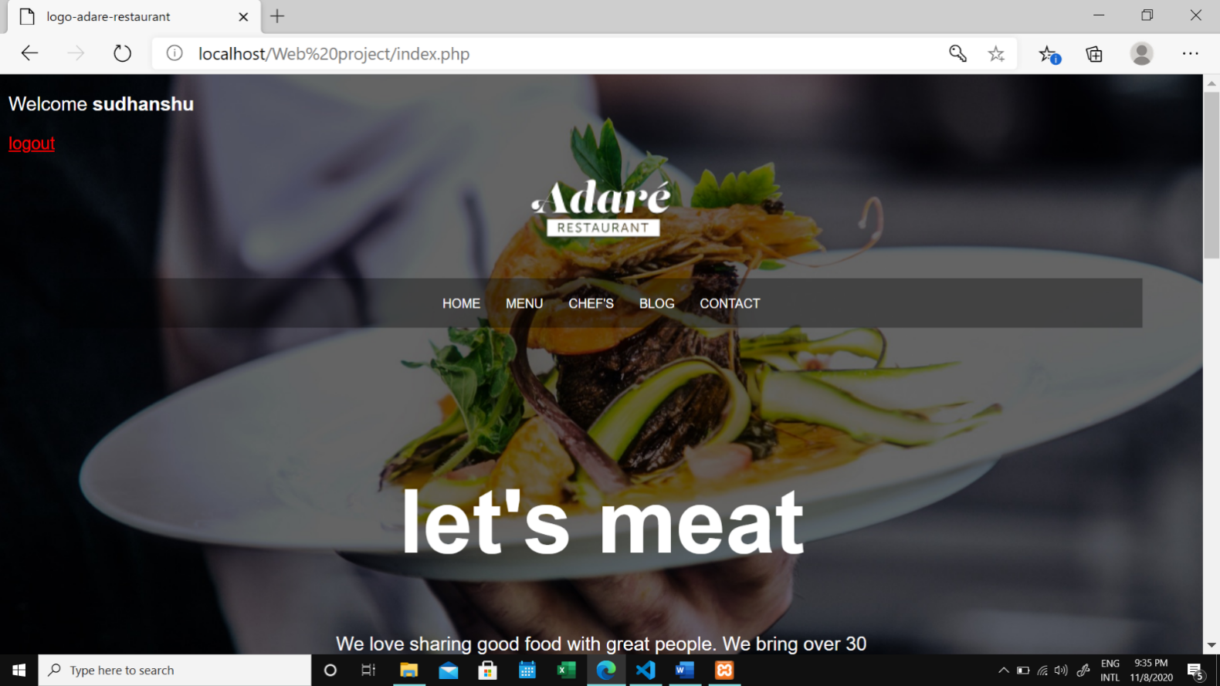

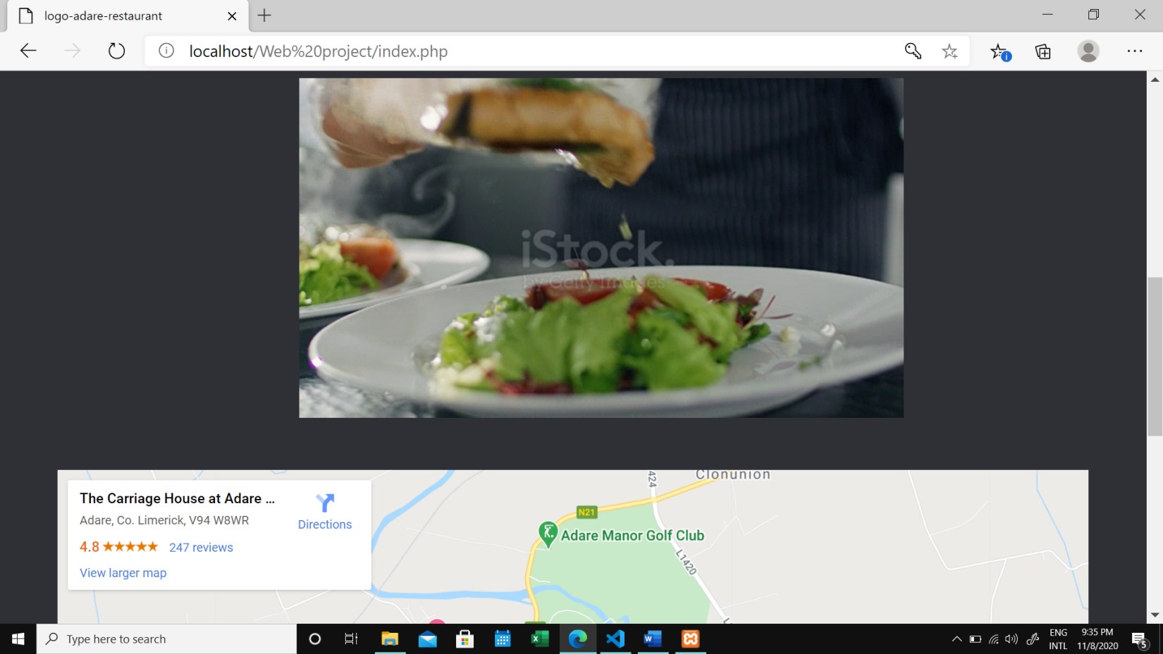

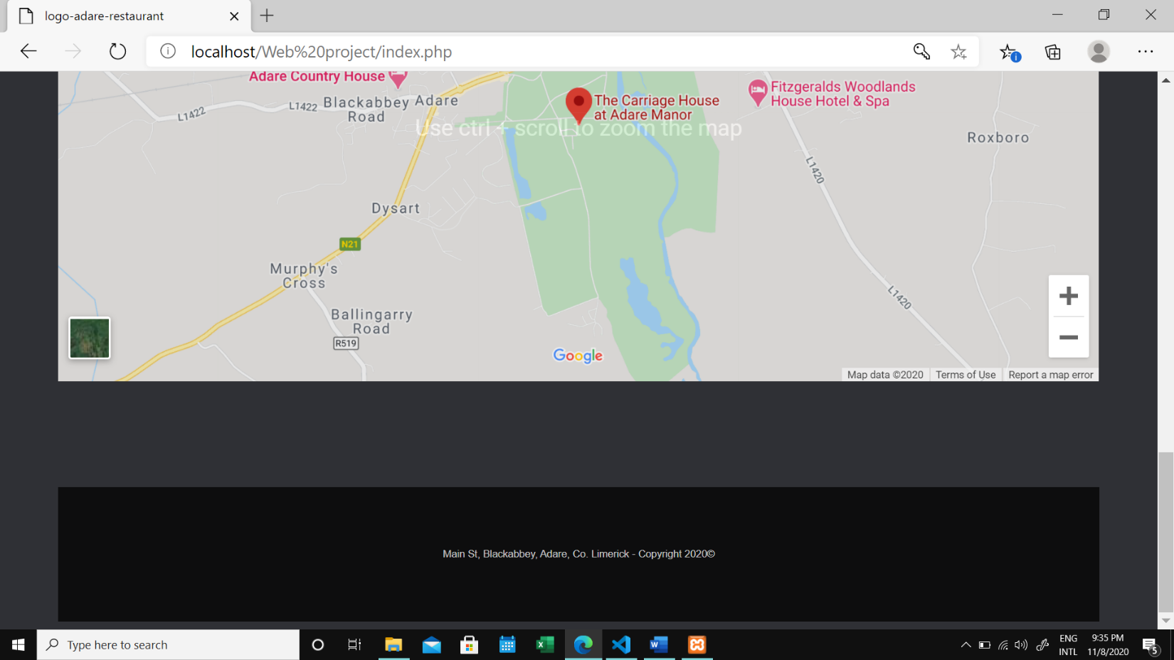

**Menu page**

Language used: -HTML5, CSS, JavaScript;

* Menu page contains an interactive menu of item served in the restaurant.
* JavaScript is used to show transformation effects in menu items to make page look much interactive.

**HTML code**

Menu.html

<!DOCTYPE html>

<html lang="en">

<head>

    <meta charset="UTF-8">

    <meta name="viewport" content="width=device-width, initial-scale=1.0">

    <title>logo-adare-restaurant</title>

    <link rel="stylesheet" href="style2.css">

    <link rel="stylesheet" href="https://stackpath.bootstrapcdn.com/bootstrap/4.5.2/css/bootstrap.min.css" integrity="sha384-JcKb8q3iqJ61gNV9KGb8thSsNjpSL0n8PARn9HuZOnIxN0hoP+VmmDGMN5t9UJ0Z" crossorigin="anonymous">

    <script src="https://code.jquery.com/jquery-3.5.1.slim.min.js" integrity="sha384-DfXdz2htPH0lsSSs5nCTpuj/zy4C+OGpamoFVy38MVBnE+IbbVYUew+OrCXaRkfj" crossorigin="anonymous"></script>

    <script src="https://cdn.jsdelivr.net/npm/popper.js@1.16.1/dist/umd/popper.min.js" integrity="sha384-9/reFTGAW83EW2RDu2S0VKaIzap3H66lZH81PoYlFhbGU+6BZp6G7niu735Sk7lN" crossorigin="anonymous"></script>

    <script src="https://stackpath.bootstrapcdn.com/bootstrap/4.5.2/js/bootstrap.min.js" integrity="sha384-B4gt1jrGC7Jh4AgTPSdUtOBvfO8shuf57BaghqFfPlYxofvL8/KUEfYiJOMMV+rV" crossorigin="anonymous"></script>

</head>

<body>

    <div class="container">

        <header>

            <img src="images/logo-adare-restaurant.png" alt="Logo for Adare Restaurant" style="background-color: black; padding: 2rem 24.85rem;">

        </header>

        <nav class="navigation">

                <a href="index.php">HOME</a>

                <a href="menu1.html">MENU</a>

                <a href="chefs.html">CHEF'S</a>

                <a href="blog.html">BLOG</a>

                <a href="contact.html">CONTACT</a>

        </nav>

        <main>

          <hr>

            <section class="order">

                <div class="container">

                  <div class="row">

                    <div class="col-md-4">

                    <a href="#">

                      <img src="images/chicken burger+fries.jpg">

                      <figcaption class="detail">Chicken Burger + Fries</figcaption>

                      <figcaption>$25</figcaption>

                    </a>

                    </div>

                    <div class="col-md-4">

                    <a href="#">

                      <img src="images/chicken burger.jpg">

                      <figcaption class="detail">Chicken Burger</figcaption>

                      <figcaption>$20</figcaption>

                    </a>

                    </div>

                    <div class="col-md-4">

                    <a href="#">

                      <img src="images/veg burger+fries.jpg">

                      <figcaption class="detail">Veg Burger + Fries</figcaption>

                      <figcaption>$20</figcaption>

                    </a>

                    </div>

                  </div>

                  <hr>

                  <div class="row">

                    <div class="col-md-4">

                    <a href="#">

                        <img src="images/veg burger.jpg">

                        <figcaption class="detail">Veg Burger</figcaption>

                        <figcaption>$15</figcaption>

                    </a>

                    </div>

                    <div class="col-md-4">

                      <a href="#">

                          <img src="images/fries.jpg">

                          <figcaption class="detail">Fries</figcaption>

                          <figcaption>$7</figcaption>

                      </a>

                      </div>

                    <div class="col-md-4">

                    <a href="#">

                        <img src="images/veg salad.jpg">

                        <figcaption class="detail">Veg Salad</figcaption>

                        <figcaption>$20</figcaption>

                    </a>

                    </div>

                  </div>

                  <hr>

                  <div class="row">

                    <div class="col-md-4">

                    <a href="#">

                        <img src="images/wraps.jpg">

                        <figcaption class="detail">Wraps</figcaption>

                        <figcaption>$20</figcaption>

                    </a>

                    </div>

                    <div class="col-md-4">

                    <a href="#">

                        <img src="images/club sandwich.jpg">

                        <figcaption class="detail">Club Sandwich</figcaption>

                        <figcaption>$17</figcaption>

                    </a>

                    </div>

                    <div class="col-md-4">

                    <a href="#">

                        <img src="images/pasta.jpg">

                        <figcaption class="detail">Pasta</figcaption>

                        <figcaption>$30</figcaption>

                    </a>

                    </div>

                  </div>

                  <hr>

                  <div class="row">

                    <div class="col-md-4">

                    <a href="#">

                        <img src="images/stir fry noodle.jpg">

                        <figcaption class="detail">Noodles</figcaption>

                        <figcaption>$20</figcaption>

                    </a>

                    </div>

                    <div class="col-md-4">

                    <a href="#">

                        <img src="images/fried chicken.jpg">

                        <figcaption class="detail">Fried Chicken</figcaption>

                        <figcaption>$30</figcaption>

                    </a>

                    </div>

                    <div class="col-md-4">

                    <a href="#">

                        <img src="images/pizza+coke.jpg">

                        <figcaption class="detail">Pizza + Coke(250ml)</figcaption>

                        <figcaption>$30</figcaption>

                    </a>

                    </div>

                  </div>

                </div>

            </section>

            <footer>

                <p>Main St, Blackabbey, Adare, Co. Limerick - Copyright 2020©</p>

            </footer>

</body>

</html>

CSS code

menu.css

.center {

    margin-left: auto;

    margin-right: auto;

  }

nav {

    background-color: rgba(0, 0, 0, 0.338);

    text-align: center;

    padding-top: 14px;

    padding-bottom: 14px;

}

nav a {

    text-decoration: none;

    font-size: 12px;

    padding-left: 10px;

    padding-right: 10px;

    color: black;

    font-weight: 700;

}

body {

    background-color: #2F3035;

    background-image: url(images/back.jpg);

    background-size: cover;

    background-repeat: no-repeat;

    background-position: center;

}

.detail {

    color: black;

    font-weight: bold;

}

footer {

    background-color: rgba(0, 0, 0, 0.728);

    padding-top: 50px;

    padding-bottom: 50px;

    text-align: center;

    color: white;

}

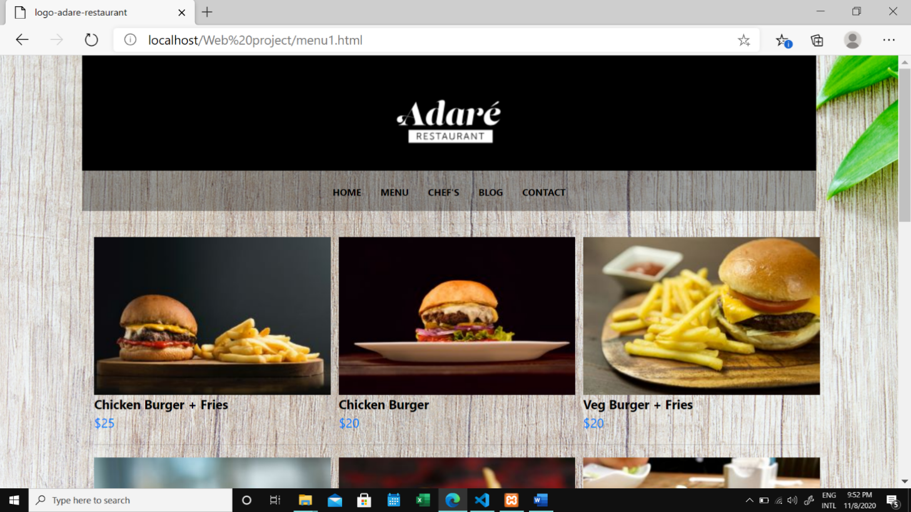

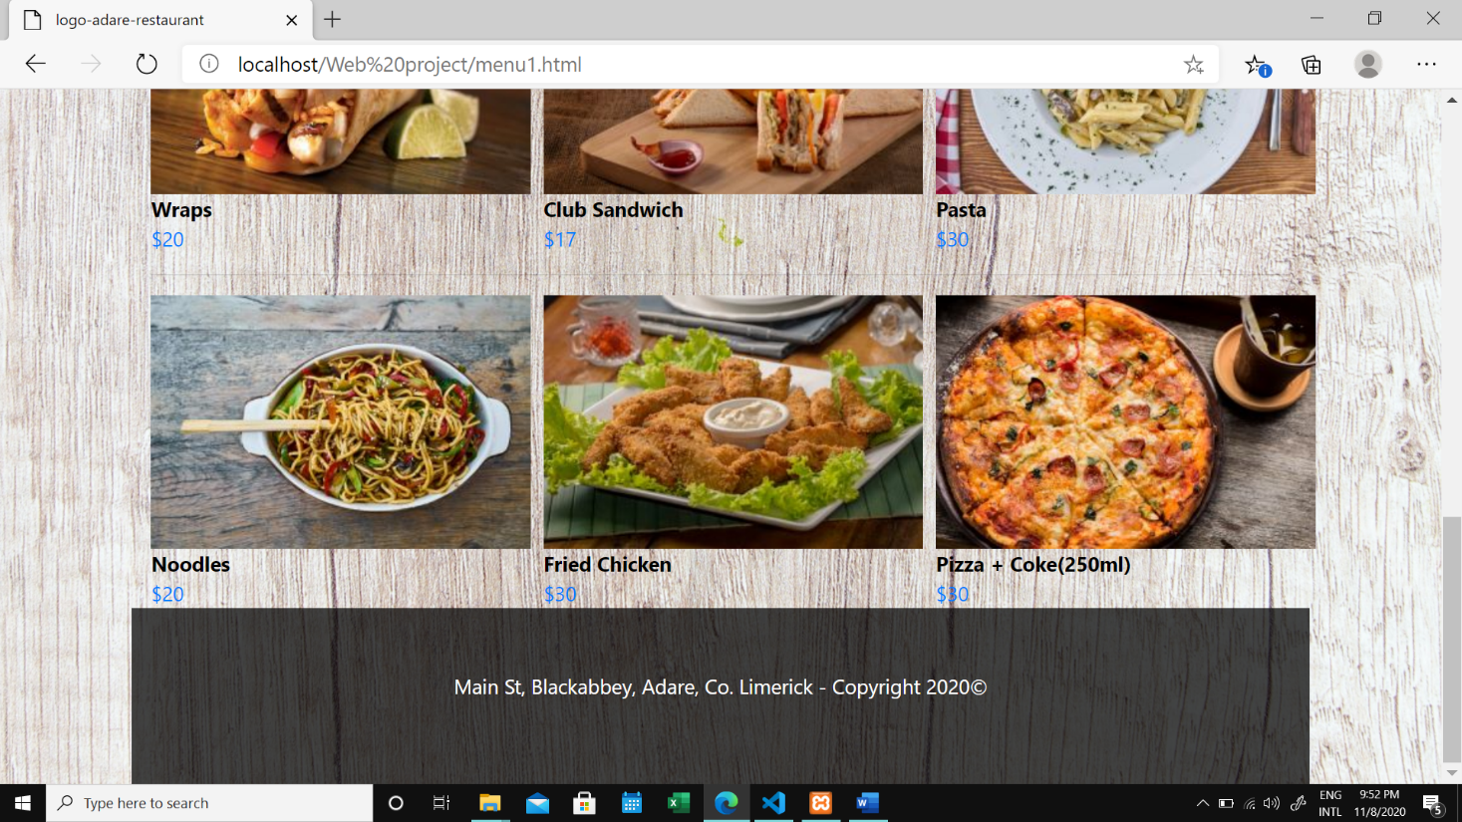

**Chef’s page**

Language used:-HTML5, CSS3.

* Chef’s page contains the info of world class Chefs which work in the Restaurant.
* Chefs also contains info about Chef’s signature dishes and their experiences.

HTML code

Chef.html

<!DOCTYPE html>

<html lang="en">

<head>

    <meta charset="UTF-8">

    <meta name="viewport" content="width=device-width, initial-scale=1.0">

    <title>logo-adare-restaurant</title>

    <link rel="stylesheet" href="style2.css">

    <link rel="stylesheet" href="https://stackpath.bootstrapcdn.com/bootstrap/4.5.2/css/bootstrap.min.css" integrity="sha384-JcKb8q3iqJ61gNV9KGb8thSsNjpSL0n8PARn9HuZOnIxN0hoP+VmmDGMN5t9UJ0Z" crossorigin="anonymous">

    <script src="https://code.jquery.com/jquery-3.5.1.slim.min.js" integrity="sha384-DfXdz2htPH0lsSSs5nCTpuj/zy4C+OGpamoFVy38MVBnE+IbbVYUew+OrCXaRkfj" crossorigin="anonymous"></script>

    <script src="https://cdn.jsdelivr.net/npm/popper.js@1.16.1/dist/umd/popper.min.js" integrity="sha384-9/reFTGAW83EW2RDu2S0VKaIzap3H66lZH81PoYlFhbGU+6BZp6G7niu735Sk7lN" crossorigin="anonymous"></script>

    <script src="https://stackpath.bootstrapcdn.com/bootstrap/4.5.2/js/bootstrap.min.js" integrity="sha384-B4gt1jrGC7Jh4AgTPSdUtOBvfO8shuf57BaghqFfPlYxofvL8/KUEfYiJOMMV+rV" crossorigin="anonymous"></script>

</head>

<body>

    <div class="container">

        <header>

            <img src="images/logo-adare-restaurant.png" alt="Logo for Adare Restaurant" style="background-color: black; padding: 2rem 24.85rem;">

        </header>

        <nav class="navigation">

                <a href="index.php">HOME</a>

                <a href="menu1.html">MENU</a>

                <a href="chefs.html">CHEF'S</a>

                <a href="blog.html">BLOGS</a>

                <a href="contact.html">CONTACT</a>

        </nav>

        <h1 style="text-align: center;">Chef's</h1>

        <br>

        <br>

        <div class="row">

            <div class="column">

              <img src="chef_img/3.jpg" alt="Chef img1" style="width: 75%;">

            </div>

            <div class="column">

                <br>

                <br>

              <h4>Head Chef</h4>

              <p>Lorem ipsum dolor sit amet, consectetur adipiscing elit, sed do pharetra sit amet</p>

              <p>eiusmod tempor incididunt ut labore et dolore magna aliqua. Vitae pharetra sit amet</p>

              <p>suscipit tellus mauris a diam maecenas sed enim. Scelerisque eu pharetra sit amet</p>

              <p>ut aliquip ex ea commodo consequat.</p>

            </div>

        </div>

        <br>

        <br>

        <div class="row">

            <div class="column">

              <img src="chef_img/1.jpg" alt="Chef img2" style="width: 75%;">

            </div>

            <div class="column">

                <br>

                <br>

              <h4>Master Chef</h4>

              <p>Lorem ipsum dolor sit amet, consectetur adipiscing elit, sed do pharetra sit amet</p>

              <p>eiusmod tempor incididunt ut labore et dolore magna aliqua. Vitae pharetra sit amet</p>

              <p>suscipit tellus mauris a diam maecenas sed enim. Scelerisque eu pharetra sit amet</p>

              <p>ut aliquip ex ea commodo consequat.</p>

            </div>

        </div>

        <br>

        <br>

        <div class="row">

            <div class="column">

              <img src="chef_img/2.jpg" alt="Chef img3" style="width: 75%;">

            </div>

            <div class="column">

                <br>

                <br>

              <h4>Assistant Chef</h4>

              <p> Lorem ipsum dolor sit amet, consectetur adipiscing elit, sed do pharetra sit amet</p>

              <p> eiusmod tempor incididunt ut labore et dolore magna aliqua. Vitae pharetra sit amet</p>

              <p> suscipit tellus mauris a diam maecenas sed enim. Scelerisque eu pharetra sit amet</p>

              <p> ut aliquip ex ea commodo consequat.</p>

            </div>

        </div>

        <br>

        <br>

        <footer>

            <p>Main St, Blackabbey, Adare, Co. Limerick - Copyright 2020©</p>

        </footer>

    </div>

</body>

CSS code

Chef.css

.center {

    margin-left: auto;

    margin-right: auto;

  }

nav {

    background-color: rgba(0, 0, 0, 0.338);

    text-align: center;

    padding-top: 14px;

    padding-bottom: 14px;

}

nav a {

    text-decoration: none;

    font-size: 12px;

    padding-left: 10px;

    padding-right: 10px;

    color: black;

    font-weight: 700;

}

body {

    background-color: #2F3035;

    background-image: url(images/back.jpg);

    background-size: cover;

    background-repeat: no-repeat;

    background-position: center;

}

.detail {

    color: black;

    font-weight: bold;

}

footer {

    background-color: rgba(0, 0, 0, 0.728);

    padding-top: 50px;

    padding-bottom: 50px;

    text-align: center;

    color: white;

}

Chef2.css

body {

    color: #40514E;

    margin: 0px;

    text-align: center;

    font-family: 'Merriweather', serif;

}

p {

    line-height: 2;

}

hr {

    border: dotted #EAF6F6 6px;

    border-bottom: none;

    width: 4%;

    margin: 100px auto;

}

a {

    color: #11999E;

    margin: 10px 20px;

    text-decoration: none;

}

a:hover {

    color: #EAF6F6;

}

.top-container {

    background-color: #ddf3f5;

    padding-top: 100px;

}

.middle-container {

    padding: 100px ,0;

}

.bottom-container {

    color: #11999E;

    background-color: #66BFBF;

    padding: 40px 0 10px;

    text-align: center;

}

.top-cloud {

    position: absolute;

    top: 40px;

    right: 300px;

}

.bottom-cloud {

    position: absolute;

    left: 250px;

    bottom: 170px;

}

.intro {

    width: 30%;

    margin: auto;

}

.contact-message {

    width: 40%;

    margin: 40px auto 60px;

}

.copyright {

    color: #EAF6F6;

    font-size: 0.75rem;

    padding: 20px 0;

}

h1 {

    font-size: 3rem;

    margin: 50px auto 0 auto;

    color: #66BFBF;

    line-height: 2;

}

h2 {

    font-size: 2rem;

    font-family: 'Galada', cursive;

    color: #66BFBF;

    font-weight: normal;

    padding-bottom: 10px;

}

h3 {

    color: #11999E;

}

.skill-row {

    width: 50%;

    margin: 100px auto 100px auto;

    text-align: left;

}

.running {

    float: right;

}

.coding {

    float: left;

    margin-right: 50px;

}

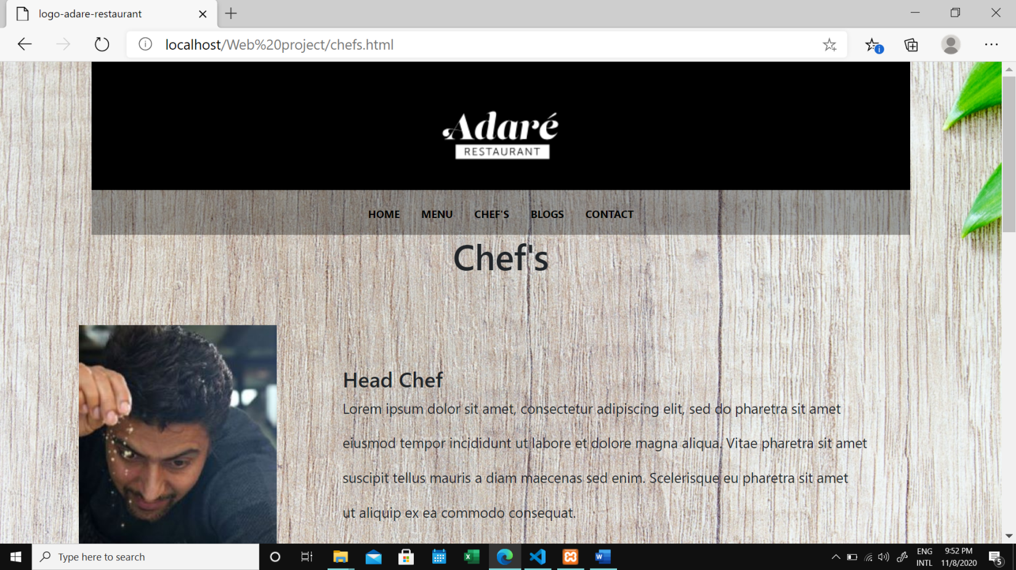

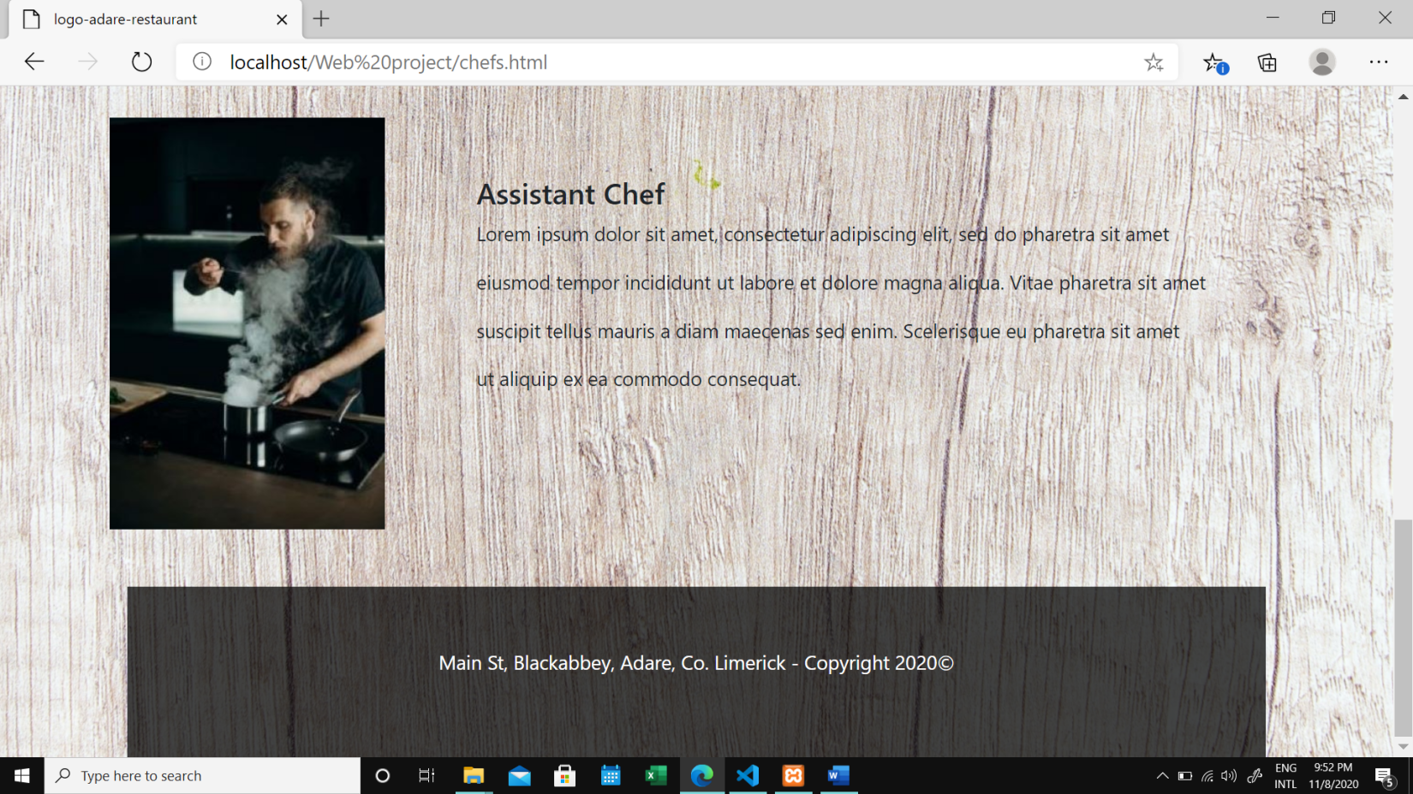

**Blog page**

Language used:-HTML5, CSS3.

* Blog page contain info about recipes of healthy food and which is updated in every week.

**HTML code**

<!DOCTYPE html>

<html lang="en">

<head>

    <meta charset="UTF-8">

    <meta name="viewport" content="width=device-width, initial-scale=1.0">

    <title>logo-adare-restaurant</title>

    <link rel="stylesheet" href="style2.css">

    <link rel="stylesheet" href="https://stackpath.bootstrapcdn.com/bootstrap/4.5.2/css/bootstrap.min.css" integrity="sha384-JcKb8q3iqJ61gNV9KGb8thSsNjpSL0n8PARn9HuZOnIxN0hoP+VmmDGMN5t9UJ0Z" crossorigin="anonymous">

    <script src="https://code.jquery.com/jquery-3.5.1.slim.min.js" integrity="sha384-DfXdz2htPH0lsSSs5nCTpuj/zy4C+OGpamoFVy38MVBnE+IbbVYUew+OrCXaRkfj" crossorigin="anonymous"></script>

    <script src="https://cdn.jsdelivr.net/npm/popper.js@1.16.1/dist/umd/popper.min.js" integrity="sha384-9/reFTGAW83EW2RDu2S0VKaIzap3H66lZH81PoYlFhbGU+6BZp6G7niu735Sk7lN" crossorigin="anonymous"></script>

    <script src="https://stackpath.bootstrapcdn.com/bootstrap/4.5.2/js/bootstrap.min.js" integrity="sha384-B4gt1jrGC7Jh4AgTPSdUtOBvfO8shuf57BaghqFfPlYxofvL8/KUEfYiJOMMV+rV" crossorigin="anonymous"></script>

</head>

<body>

    <div class="container">

        <header>

            <img src="images/logo-adare-restaurant.png" alt="Logo for Adare Restaurant" style="background-color: black; padding: 2rem 24.85rem;">

        </header>

        <nav class="navigation">

                <a href="index.php">HOME</a>

                <a href="menu1.html">MENU</a>

                <a href="chefs.html">CHEF'S</a>

                <a href="blog.html">BLOGS</a>

                <a href="contact.html">CONTACT</a>

        </nav>

        <!--Blog Section-->

        <section class="blog-section">

            <div class="container">

                <div class="row justify-content-center mb-5">

                    <div class="col-md-7 blog-heading text-center">

                        <h2>Recent Blog</h2>

                    </div>

                </div>

                <div class="row d-flex">

                    <div class="col-lg-6 d-flex align-items-stretch">

                        <div class="blog-start d-flex">

                            <a href="#"class="block-20 img"

                            style="background-image: url('images/prod-1.jpg');">

                            </a>

                            <div class="text p-4 bg-light">

                                <div class="des">

                                    <p><i class="fa fa-calendar"></i>

                                    24 October 2020

                                    </p>

                                </div>

                                <h3 class="heading mb-3">

                                    <a href="#">

                                        5 minute magic green sauce

                                    </a>

                                </h3>

                                <p>Magic Green Sauce? Made with all green foods // whipped ...</p>

                                <a href="https://pinchofyum.com/5-minute-magic-green-sauce" class="btn-custom">Continue

                                    <i class="fa fa-long-arrow-right"></i>

                                </a>

                            </div>

                        </div>

                    </div>

                    <!----->

                    <div class="col-lg-6 d-flex align-items-stretch">

                        <div class="blog-start d-flex">

                            <a href="#"class="block-20 img"

                            style="background-image: url('images/prod-2.jpg');">

                            </a>

                            <div class="text p-4 bg-light">

                                <div class="des">

                                    <p><i class="fa fa-calendar"></i>

                                    20 October 2020

                                    </p>

                                </div>

                                <h3 class="heading mb-3">

                                    <a href="#">

                                        The Best Chicken Tinga Tacos

                                    </a>

                                </h3>

                                <p>These Chicken Tinga Tacos are THE BEST! Saucy, spicy, real…</p>

                                <a href="https://pinchofyum.com/the-best-chicken-tinga-tacos" class="btn-custom">Continue

                                    <i class="fa fa-long-arrow-right"></i>

                                </a>

                            </div>

                        </div>

                    </div>

                    <!----->

                    <div class="col-lg-6 d-flex align-items-stretch">

                        <div class="blog-start d-flex">

                            <a href="#"class="block-20 img"

                            style="background-image: url('images/prod-3.jpg');">

                            </a>

                            <div class="text p-4 bg-light">

                                <div class="des">

                                    <p><i class="fa fa-calendar"></i>

                                    16 October 2020

                                    </p>

                                </div>

                                <h3 class="heading mb-3">

                                    <a href="#">

                                        The best Soft Chocolate Chip Cookies

                                    </a>

                                </h3>

                                <p>These are THE BEST soft chocolate chip cookies! No chilling…</p>

                                <a href="https://pinchofyum.com/the-best-soft-chocolate-chip-cookies" class="btn-custom">Continue

                                    <i class="fa fa-long-arrow-right"></i>

                                </a>

                            </div>

                        </div>

                    </div>

                    <!----->

                    <div class="col-lg-6 d-flex align-items-stretch">

                        <div class="blog-start d-flex">

                            <a href="#"class="block-20 img"

                            style="background-image: url('images/prod-4.jpg');">

                            </a>

                            <div class="text p-4 bg-light">

                                <div class="des">

                                    <p><i class="fa fa-calendar"></i>

                                    12 October 2020

                                    </p>

                                </div>

                                <h3 class="heading mb-3">

                                    <a href="#">

                                        Favorite Browned Butter Chocolate Chip Cookies

                                    </a>

                                </h3>

                                <p>Browned butter and brown sugar caramely goodness,

                                     crispy edges, barely thick and soft ...</p>

                                <a href="https://pinchofyum.com/browned-butter-chocolate-chip-cookies" class="btn-custom">Continue

                                    <i class="fa fa-long-arrow-right"></i>

                                </a>

                            </div>

                        </div>

                    </div>

                    <!----->

                </div>

            </div>

        </section>

        <!-- End of Blog Section-->

        <footer>

            <p>Main St, Blackabbey, Adare, Co. Limerick - Copyright 2020©</p>

        </footer>

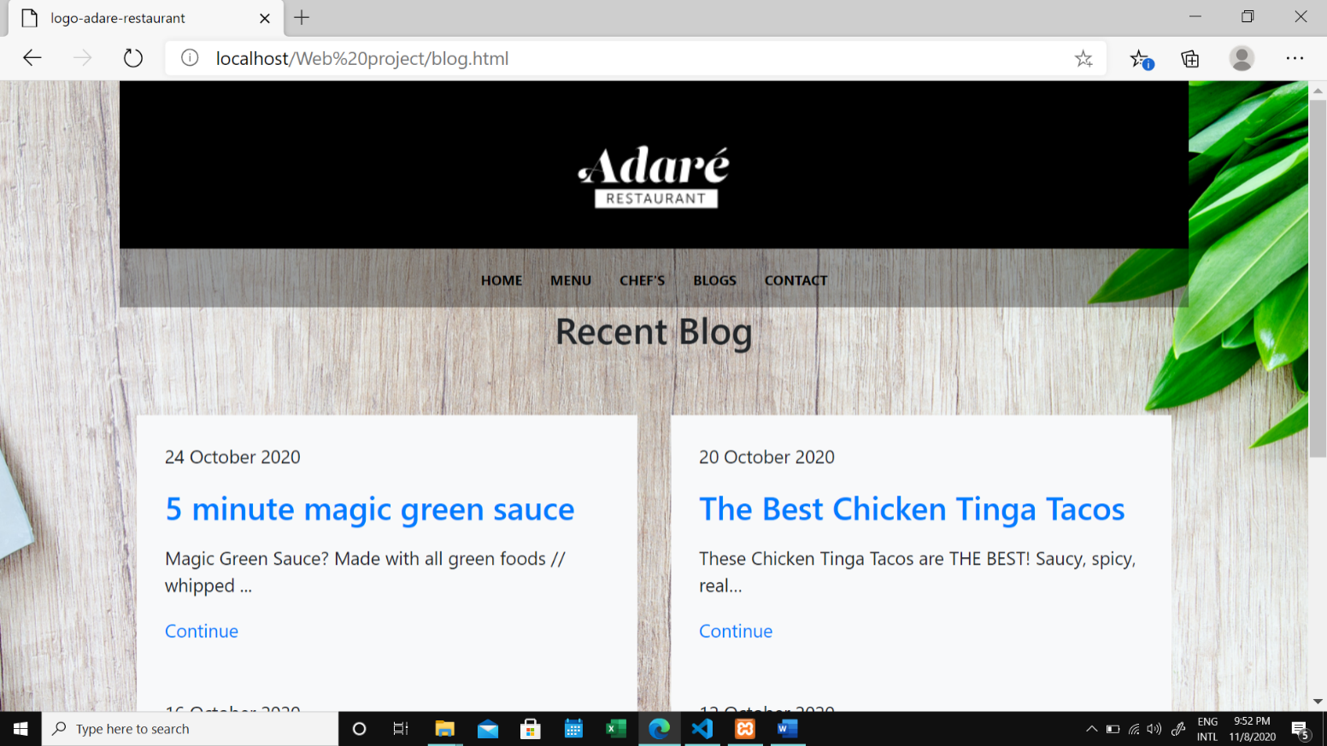

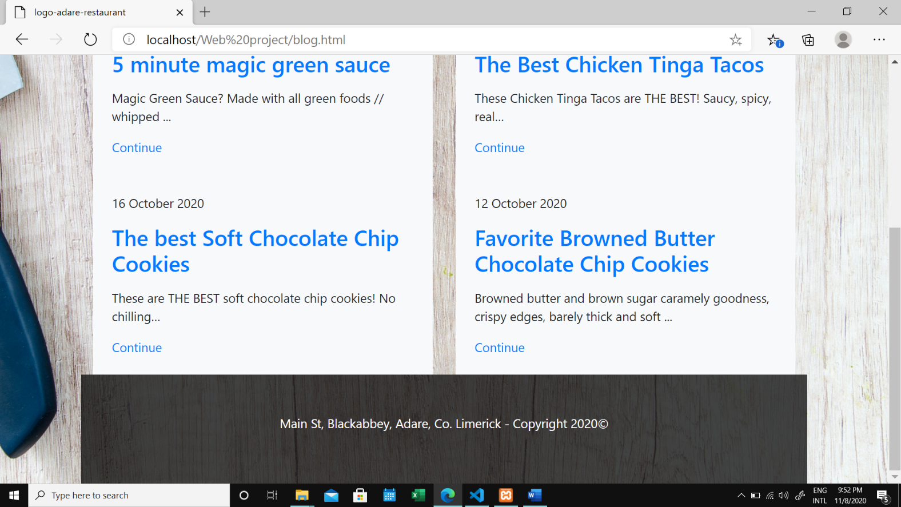

**Contact page**

Language used: -HTML5, CSS3.

* Contact page contains Restaurant contact number and email id for contact.
* It also contains a feedback form for customer to gave feedback.
* Feedback form contains sections like

**HTML code**

<!DOCTYPE html>

<html lang="en">

<head>

    <meta charset="UTF-8">

    <meta name="viewport" content="width=device-width, initial-scale=1.0">

    <title>logo-adare-restaurant</title>

    <link rel="stylesheet" href="style2.css">

    <link rel="stylesheet" href="https://stackpath.bootstrapcdn.com/bootstrap/4.5.2/css/bootstrap.min.css" integrity="sha384-JcKb8q3iqJ61gNV9KGb8thSsNjpSL0n8PARn9HuZOnIxN0hoP+VmmDGMN5t9UJ0Z" crossorigin="anonymous">

    <script src="https://code.jquery.com/jquery-3.5.1.slim.min.js" integrity="sha384-DfXdz2htPH0lsSSs5nCTpuj/zy4C+OGpamoFVy38MVBnE+IbbVYUew+OrCXaRkfj" crossorigin="anonymous"></script>

    <script src="https://cdn.jsdelivr.net/npm/popper.js@1.16.1/dist/umd/popper.min.js" integrity="sha384-9/reFTGAW83EW2RDu2S0VKaIzap3H66lZH81PoYlFhbGU+6BZp6G7niu735Sk7lN" crossorigin="anonymous"></script>

    <script src="https://stackpath.bootstrapcdn.com/bootstrap/4.5.2/js/bootstrap.min.js" integrity="sha384-B4gt1jrGC7Jh4AgTPSdUtOBvfO8shuf57BaghqFfPlYxofvL8/KUEfYiJOMMV+rV" crossorigin="anonymous"></script>

</head>

<body>

    <div class="container">

        <header>

            <img src="images/logo-adare-restaurant.png" alt="Logo for Adare Restaurant" style="background-color: black; padding: 2rem 24.85rem;">

        </header>

        <nav class="navigation">

                <a href="index.php">HOME</a>

                <a href="menu1.html">MENU</a>

                <a href="chefs.html">CHEF'S</a>

                <a href="blog.html">BLOGS</a>

                <a href="contact.html">CONTACT</a>

        </nav>

        <div class="contact">

        <h1>Contact Information</h1>

        <p>Phone -- xxxxxxxxxx</p>

        <p>Email -- sudhanshunimje@gmail.com</p>

        <iframe src="https://docs.google.com/forms/d/e/1FAIpQLScWbL5A9XViYF93L2r9dymVuXLEqRFNgio0Idem640UJT4E-A/viewform?embedded=true" width="950" height="2260" frameborder="0" marginheight="0" marginwidth="0">Loading…</iframe>

        </div>

        <footer>

            <p>Main St, Blackabbey, Adare, Co. Limerick - Copyright 2020©</p>

        </footer>

